Exercise No:4

Date: 15.10.20

Aim: To print a single string from two set of string and swap the first two characters of each string.

Program:

def convert(s):

new=""

for x in s:

new+=x

return new

a=input()

b=input()

s1=a.strip()

s2=b.strip()

if(len(s1)>=2 and len(s2)>=2):

t1=list(s1)

t2=list(s2)

c1=t1[0]

c2=t1[1]

t1[0]=t2[0]

t1[1]=t2[1]

t2[0]=c1

t2[1]=c2

s1=convert(t1)

s2=convert(t2)

print(s1,"",s2)

else:

print("invalid")

Link:

[http://103.53.53.18/mod/vpl/forms/edit.php?id=234&userid=1702#](http://103.53.53.18/mod/vpl/forms/edit.php?id=234&userid=1702)

Output:

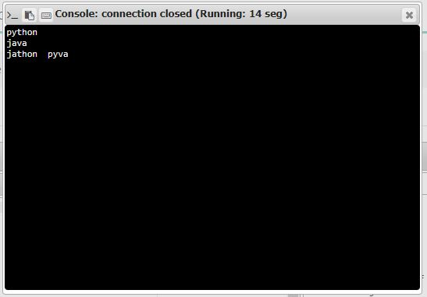

Result:

Thus the program has been successfully executed and the output is verified.